Notes on Intoxylizer 8000

- Intoxylizer 8000 in Mr. Golub’s Case
The Intoxylizer 8000 (used to collect a breath sample from Mr. Golub) was developed in 1999, and in recent decades had been discontinued due to gross errors, not only producing erroneous readings, but most importantly, failing to give an error message when the machine should have been made one (Florida v. Lance Conley). Thus, unless the operator is familiar with the quirks of the machine, there is little reliability in the result, especially (as in the case of Mr. Golub) when only one sample is collected and the time of sample collection is not continuous and exceeds 20 seconds (Mr. Golub’s sample was 140 seconds) (Short, 2009).
Indeed, the Intoxilyzer 8000 has been widely scrutinized for its potential to produce unreliable results, as seen in multiple court cases, including Florida v. Lance Conley. These machines are often referred to as “magic black boxes” in court due to their frequent anomalies and lack of transparency in how they function (Cowley and Silver-Greenberg, 2019). Despite being a cornerstone in DUI cases, numerous investigations, such as a 2019 New York Times article, have revealed how easily these devices can yield inflated or false-positive results due to improper calibration, user error, or mechanical malfunction (Cowley and Silver-Greenberg, 2019). Indeed, multiple states have thrown out their Intoxilyzer 8000 machines, with Massachusetts and New Jersey alone throwing out over 30,000 (Cowley and Silver-Greenberg, 2019).
Moreover, not only is the machine itself unreliable but the administration of the test had several significant anomalies. As a reference, below is shown a normal printout from the Intoxilyzer 8000 (Ohio Department of Health Alcohol and Drug Testing Subject Test Report, 2019) and the one presented in Cpl. Ernstsen’s DUI Report:

Ohio Department of Health, 2019
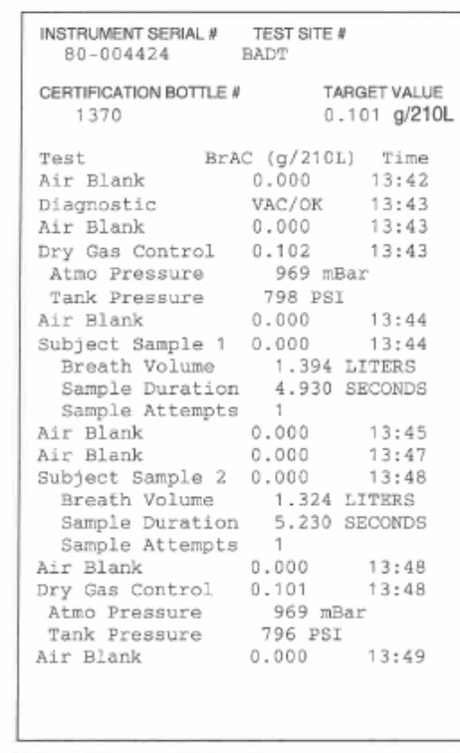
Brock Ernstsen, 2023
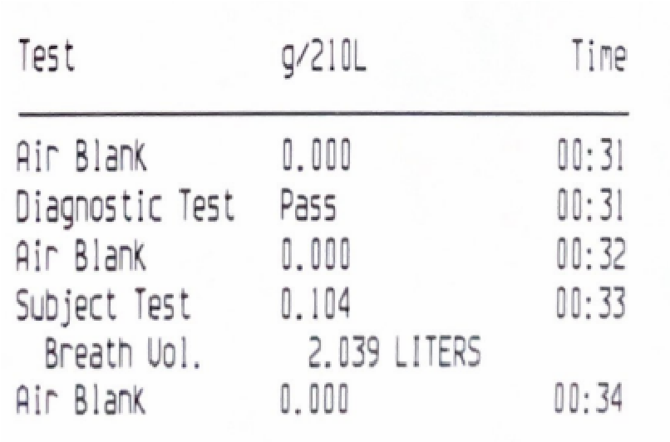
In the rest of this section, the defense will make particular reference to i) duration, ii) breath volume, and iii) sample number represented in the above printouts.

II. The main issues with the Intoxilyzer 8000's slope detection are as follows:
1. Slowness of the System
- The Intoxilyzer 8000 operates at a slow pulse rate of 2 Hz, which makes it difficult to obtain accurate slope detection. This slowness leads to missed indications of mouth alcohol in up to 40% or more of cases, as highlighted in studies like the Staubus Report1.
2. Inaccuracy in Mouth Alcohol Detection
- The slope detector is designed to differentiate between mouth alcohol (from recent drinking, burping, or regurgitation) and deep lung alcohol. However, it frequently fails to function as intended, resulting in false positives or inaccurate readings45.
- Experiments show that even individuals with no alcohol in their blood can produce positive readings after rinsing with mouthwash or similar solutions containing alcohol45.
3. Weak Signal Levels
- The system's weak signal level (6–10 mV) combined with a lack of precision at lower levels affects its ability to accurately analyze breath samples1.
4. Averaging of Readings
- To compensate for its slow operation, the Intoxilyzer 8000 averages pulses over time, which causes a lag in "real-time" analysis and reduces the reliability of results1.
5. Lack of Consistency Between Samples
- The device often fails to achieve consistent agreement between first and second breath samples, which can result in accusations of non-cooperation or refusal1.
6. Sensitivity to Interferents
- The machine struggles to distinguish ethanol from other hydrocarbons or interferents (e.g., acetone, solvents), leading to incorrect results when such substances are present during testing12.
These issues highlight significant flaws in the Intoxilyzer 8000's slope detection capabilities, raising concerns about its reliability for evidentiary use in DUI cases.

III. What specific components of the Intoxilyzer 8000 are critical for infrared absorption


+5
sources
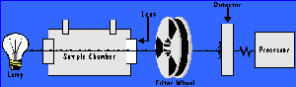
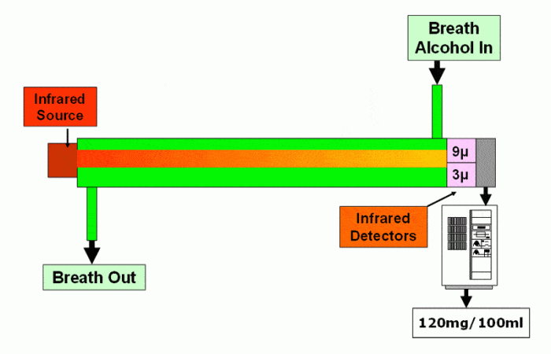

The Intoxilyzer 8000 uses several critical components for infrared absorption, which are essential for its operation in measuring breath alcohol concentration. These components include:
1. Infrared Source Lamp
- Produces infrared energy within specific wavelengths required for alcohol detection (e.g., 3.4 µm and 9.36 µm).
- The lamp emits energy that passes through the sample chamber and interacts with alcohol molecules.
- In the Intoxilyzer 8000, a pulsed source is used, which heats and cools rapidly to produce modulated energy at a frequency of 2–4 times per second125.
2. Optical Filters
- Filters infrared light at specific wavelengths to isolate signals related to ethanol absorption while minimizing interference from other compounds.
- For example, the 3.4 µm filter identifies alcohol and interferents, while the 9.36 µm filter focuses on alcohol detection25.
3. Sample Chamber
- A thermostatically controlled chamber (maintained at 47°C) where the breath sample is analyzed.
- Prevents condensation and ensures consistent analysis conditions25.
4. Infrared Detectors
- Pyroelectric detectors measure the amount of infrared light not absorbed by alcohol molecules in the sample.
- Converts absorbed energy into an electrical response, which is processed to calculate alcohol concentration25.
These components work together to implement the Lambert-Beer Law, which correlates the amount of infrared light absorbed by ethanol molecules with their concentration in the breath sample6.

Iv. Common Defenses Against the Intoxilyzer 8000

Here are common defenses against the Intoxilyzer 8000's readings, as identified in legal and technical analyses:
1. Calibration and Maintenance Issues
- The Intoxilyzer 8000 requires regular calibration and maintenance to ensure accurate readings. If records show that the device was not properly calibrated or maintained, its results can be deemed unreliable134.
- Defense attorneys often request calibration logs to identify gaps or inconsistencies.
2. Operator Error
- Improper administration of the test by law enforcement officers can lead to inaccurate results. For example, failing to observe the mandatory pre-test observation period (to avoid contamination from residual mouth alcohol) or mishandling the device can be grounds for challenging the results5.
3. Interfering Substances (Interferent Detect Error)
- The Intoxilyzer 8000 may misinterpret non-alcoholic substances like acetone (common in diabetics) or other hydrocarbons as alcohol, leading to false positives. This is flagged as an "Interferent Detect" error, which can be used to question the reliability of the test12.
4. Medical Conditions
- Certain medical conditions, such as GERD (gastroesophageal reflux disease), diabetes (producing acetone), or recent dental work, can affect breath test accuracy by introducing residual alcohol or interfering substances into the sample56.
5. Volume and Lung Capacity Errors
- The Intoxilyzer 8000 has been found to produce results requiring breath volumes that exceed human lung capacity. This raises questions about its accuracy, especially for individuals with compromised lung function2.
6. Margin of Error
- Breathalyzers like the Intoxilyzer 8000 have an inherent margin of error due to their reliance on indirect measurements of blood alcohol concentration (BAC). Highlighting this margin can cast doubt on borderline BAC readings4.
7. Environmental Factors
- External factors like ambient air contamination or improper clearing of the sample chamber ("Ambient Fail" error) can skew results. Defense attorneys may argue that these factors compromised the test's validity15.
8. Lack of Consistency Between Samples
- If two required breath samples show significant discrepancies, this inconsistency can undermine the reliability of the results and suggest equipment malfunction or operator error2.
9. Expert Testimony
- Defense attorneys often call upon forensic experts to explain technical flaws in the Intoxilyzer 8000's design, operation, or maintenance and how these could have affected the BAC readings15.
10. Legal Challenges
- Filing motions to suppress evidence based on procedural errors (e.g., failure to follow testing protocols) or technical flaws in the device is a common defense strategy13.
By leveraging these defenses, attorneys can challenge the reliability and admissibility of Intoxilyzer 8000 results in DUI cases.

V. Relevant Peer-Reviewed Articles and Publications

i. Difference Between Breath Alcohol Test and Blood Alcohol Test
- "Breathalyzer Test: How It Works, What It Measures, and Accuracy"
  - Explains the mechanism of breath alcohol tests, which estimate blood alcohol concentration (BAC) based on a fixed partition ratio of 2,100:1 (breath to blood).
  - Highlights that breath tests are less invasive but can be influenced by environmental factors and physiological conditions like temperature or mouth alcohol.
  - Blood tests are considered more accurate as they directly measure alcohol in the bloodstream but are more invasive and require laboratory analysis.
[Source: Medical News Today]1
- "Blood Tests vs. Breath Tests: Measuring Reliability"
  - Discusses discrepancies between breath test readings and blood test results, with blood tests generally being more accurate.
  - Notes that breath tests can over- or under-report BAC due to variations in absorption, distribution, and elimination phases of alcohol metabolism.
  - Cites studies showing differences of up to 15% between the two methods.
[Source: William Christoph Law]3
- "Comparison of Breath- and Blood-Alcohol Concentrations in a Controlled Drinking Study"
  - A peer-reviewed study comparing breath alcohol concentration (BrAC) and blood alcohol concentration (BAC).
  - Found that BAC was, on average, 11.3% higher than BrAC due to differences in measurement techniques and physiological factors.
[Source: Journal of Analytical Toxicology]5
ii. Problems with Intoxilyzer 8000 Breath Analysis vs Blood Test
- "Problems with the Intoxilyzer 8000 in Florida"
  - Highlights issues with the Intoxilyzer 8000's infrared spectroscopy method, including errors in volume measurement and sensitivity to interferents like acetone (common in diabetics or fasting individuals).
  - Notes that the device requires a minimum breath sample volume of 1.1 liters, but software flaws can produce results even when this threshold is not met.
[Source: Sammis Law Firm]4
- "Interferent Detect Problems on Florida's Intoxilyzer 8000"
  - Discusses how the Intoxilyzer 8000 may misidentify substances like acetone as ethanol, leading to false positives.
  - Explains that "Interferent Detect" errors occur when light absorption patterns do not align with ethanol alone, indicating possible contamination or device malfunction.
[Source: Sammis Law Firm]6
- "Intoxilyzer 8000 Instrumentation Manual"
  - Provides technical details about the device's reliance on infrared light for analysis and highlights its limitations compared to blood tests, which use gas chromatography for direct alcohol quantification.
[Source: Oklahoma.gov]8
These resources provide a comprehensive understanding of the differences between breath and blood alcohol tests and the specific issues associated with the Intoxilyzer 8000's reliability compared to blood testing methods.

